# **D-Mould Step-By-Step Tutorial**

**Youtube video tutorial link:** [**https://youtu.be/zo8Bf4FP3qM**](https://youtu.be/zo8Bf4FP3qM)

# **Welcome to D-Mould. In this video we will show you how to get the D-Mould ROSE-AP up and running.**

# **To begin with, you need to install a .NET5**

**Navigate to .NET5 official website.**

<https://dotnet.microsoft.com/en-us/download/dotnet/5.0>

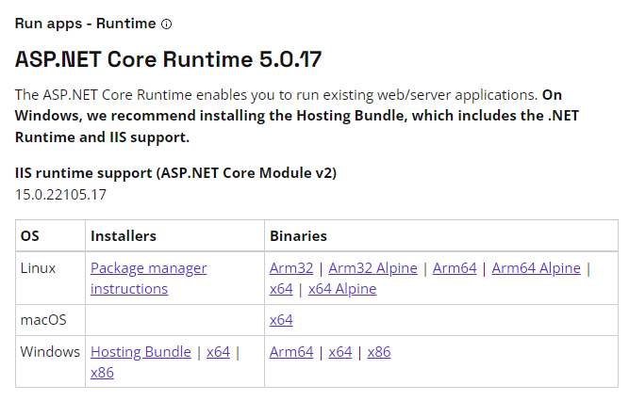

**Choose the x64 Installer for Windows and download it. Once downloaded, follow the standard installation wizard.**

# **After successfully installing the .NET5, move onto the installation of** **docker. Download Docker engine distribution from official website.**

**Docker used in the experiment was windows distribution version 4.8.2 so makes sure you pick the correct version.**

<https://www.docker.com/products/docker-desktop/>

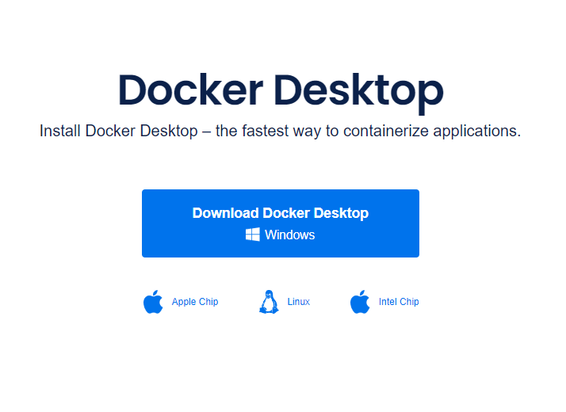

**For successful installation of the Docker, follow the Docker installation instructions. We will be installing it from the command line.**

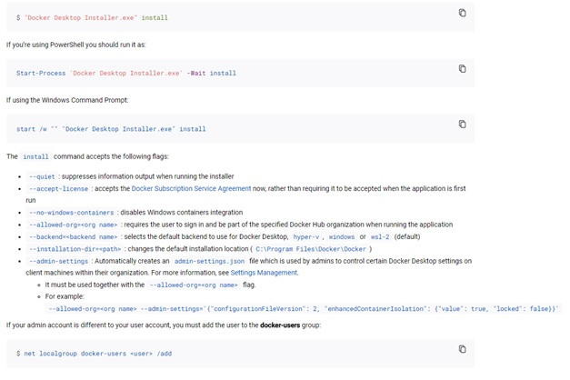

**If you prefer installation through installer wizard it is possible to do that as well.**

**During the installation it is important to select WSL 2 instead of Hyper-V. This option is only for Windows OS.**

**Turn on the WSL 2 backend. The official instructions are available on Docker documentation web portal:**

<https://docs.docker.com/desktop/windows/wsl/>

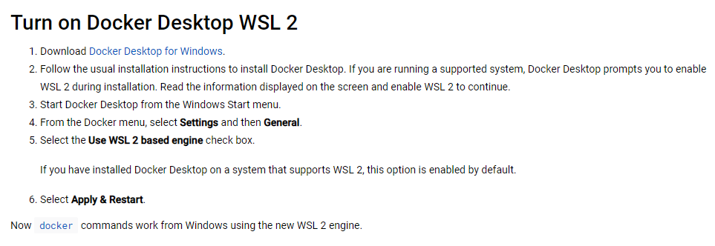

**Next up, download the software through git command of directly from github repository**

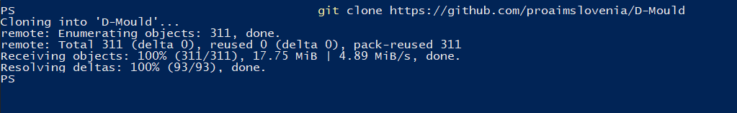

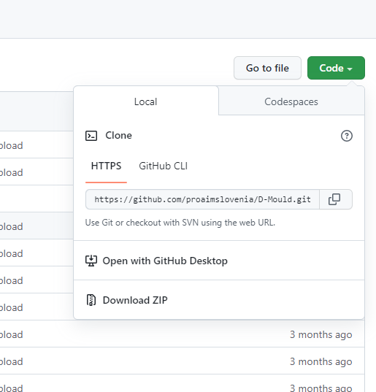

# **Now we will start the application.**

**Run the OPC UA server application from your git clone directory (\x64\D-MouldOpc.exe). It is important that you have physical connection to the hardware equipment to the nodes in the OPC are filled with data properly.**

**Let the console application run in the background. The output will be similar as one on the picture below:**

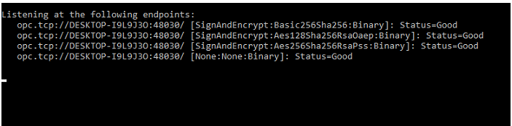

**docker-compose.yml shows all the required information regarding ports and network configuration, as well as the environment variables for the containers that require them.**

**In the \config\config.properties you can change the configuration of the docker image, endpoint addresses and ports. This is especially important if the OPC UA server application is running on different machine than docker image with Fiware Orion context broker.**





**Once the configurations are prepared, OPC UA server application is running and hardware is properly connected you can start the docker image.**

**Navigate to the folder containing the docker-compose and start the PowerShell or command line in this directory. Insert the following command:**

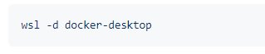

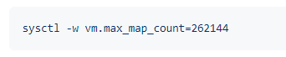

**This settings are important for the Orion context broker to start properly. Once the configuration is done, start new PowerShell or command line in the same directory and insert the following command:**

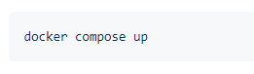

**You should see a similar output as on image below.**

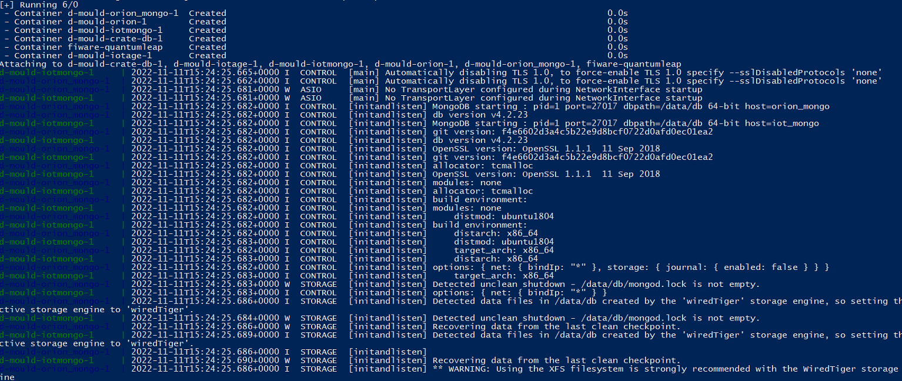

**Observe the output in the console for possible mistakes done during the editing of the configuration files.**

**Once startup is done, you can navigate to WSL IP and port 4200 to see CrateDB dashboard. Data will be inserted while machine is operating.**

**Congratulations, you’ve now successfully completed the installation!**

**\*in case support is needed, please contact** [**info@flexido.eu**](mailto:info@flexido.eu)